Sequence Diagram: Event Registration
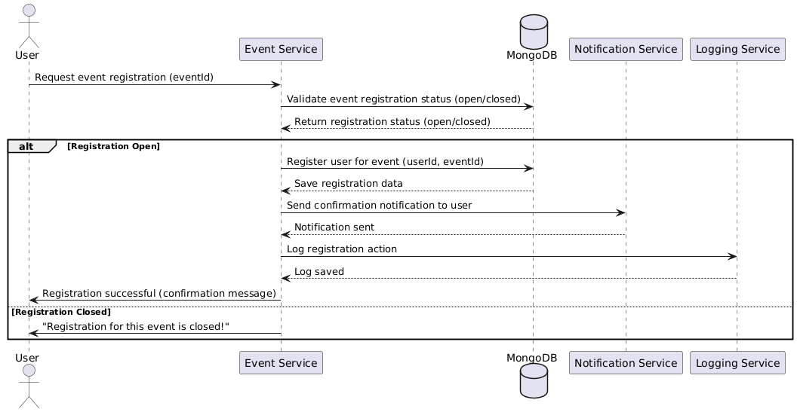

Database:
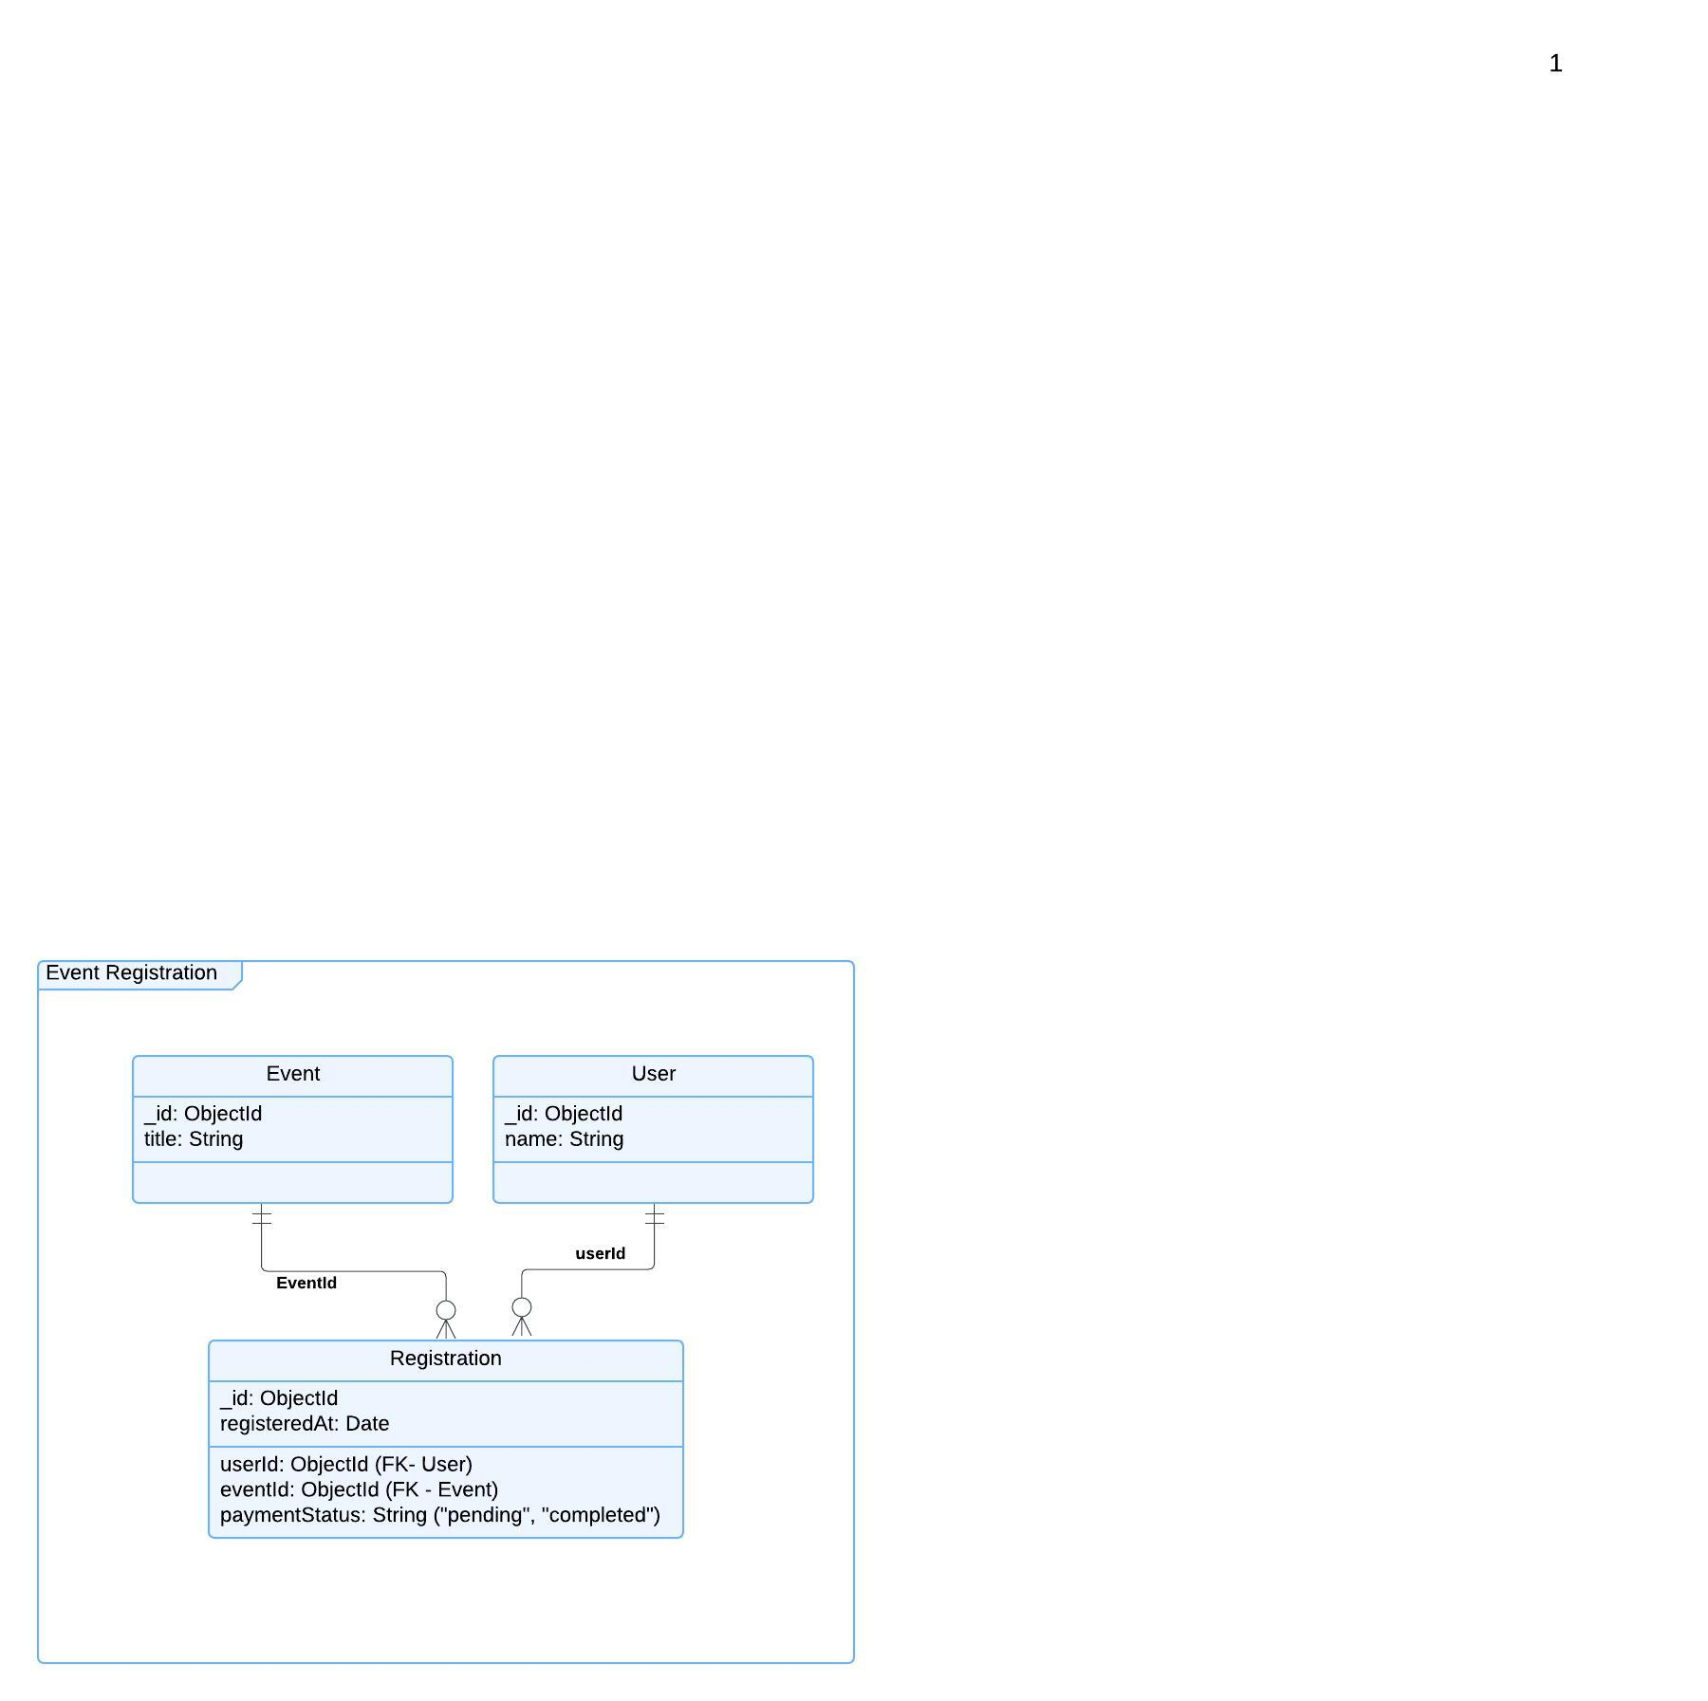

Functional Requirements (FRs)
- FR1: The system shall allow users to register for events.
- FR2: The system shall validate if event registration is open before proceeding.
- FR3: The system shall send confirmation emails after successful registration.
Non-Functional Requirements (NFRs)
- NFR1: Registration should be completed in under 2 seconds.
- NFR2: The system must handle at least 100,000 registrations per hour during peak load.

